Daniel 7 - the Four Beasts Prophecy - Part 1
There are many types of dreams. Some dreams are happy. Some dreams are surreal. Some dreams are terrifying. Some dreams are troubling. When I say a dream is troubling, I am not talking about something that makes you wake up in a cold sweat, I am talking about the dreams that make you think about it for hours, or even years, after the dream.
For years I had such a dream that would come a couple times a year. The dream started when I was a late teen and continued until I was in my 30s. In my dream, I was walking through a beautiful park. As soon as the dream started, I knew I was back in “the dream”. People were all around, looking trapped and disturbed and everything was silent. I tried to speak, tried to bring hope, but no sound came from my mouth. After trying several times, I found myself at a path crossing in the middle of the park. At the center of the crossing was a large metal sphere with a single strong door. Suddenly I am inside the sphere and someone in uniform is looking in at me. He says nothing, but somehow communicates to me that I am being punished for trying to speak. At that point he threw in a hand grenade and slammed the door shut. I woke up each time as the grenade exploded.
Each time I had that dream, it would be the focus of my thought for days or weeks thereafter. Even now as I describe it, I feel anxiety. I had the dream less frequently in my late 20s as I committed myself to do ministry, but it would continue. The dream would often occur before mission trips to Eastern Europe. It would also occur often when I had a decision coming that would determine the future of my ministry commitments. The last time I remember having that dream was shortly before leaving on a 6 week-long trip to serve God in China.
I have come to believe that God was giving me this dream to test my willingness to share His word and hope in the face of persecution. I could be totally wrong about my interpretation of this dream. But even if I was wrong, the dream and the interpretation as I understand it have made a lasting impact on my life.
Daniel had experience in interpreting dreams. He interpreted the dreams of Nebuchadnezzar: the dream of the great tree, and the dream of the statue. But this time the dream is Daniel’s and the dream troubles him.
As we go through the second half of Daniel, one thing that confuses people is that the timeline jumps around. The book started off in chapters 1-4 during the reign of Nebuchadnezzar, two weeks ago we spoke of the feast of Nebuchadnezzar’s grandson Belshazzar at the end of his reign, then we moved forward to the time of Darius who conquered Belshazzar. Now we jump back in Daniel’s life to the first year of Belshazzar. But in terms of prophecy, we are repeating the prophecies of Daniel 3. In Daniel 3, we saw this in terms of an idol made of Gold, Silver, Bronze, Iron and Clay., now we see the same prophetic times in terms of different beasts.
This week, we will see how rulers and nations are appointed by God. We will then look at the four beasts of this prophecy. Finally, we will examine how we are part of the eternal kingdom right now.

Rulers and nations are appointed by God
Daniel 7:1-3,15
“1 ¶ In the first year of Belshazzar king of Babylon Daniel saw a dream and visions in his mind as he lay on his bed; then he wrote the dream down and related the following summary of it. 2 Daniel said, "I was looking in my vision by night, and behold, the four winds of heaven were stirring up the great sea. 3 "And four great beasts were coming up from the sea, different from one another.
15 ¶ "As for me, Daniel, my spirit was distressed within me, and the visions in my mind kept alarming me.
This started as a dream, but apparently the dream didn’t end when he woke up as it then says it continued as a vision in his thoughts. Its not just that he was thinking about it, but it was so clear that he could still see it while he was awake, it was truly one of those troubling dreams.
As the dreams continue, so does Daniel’s distress.
The symbolism of the dream starts with the very beginning. So this starts our study of Biblical Symbolism: I would suggest you start keeping a list of how these symbols are used. Please note, these are not always used in exactly the same way, but as we see symbols repeated we tend to see a pattern in the ways they are used.
- Wind: Holy Spirit
- Sea: The non-Jewish nations / the gentile nations
- Beasts: Nations and Rulers
- Those standing by: God’s people Daniel 7:10

The four beasts‌ Daniel 7:4-7
17 ‘These great beasts, which are four in number, are four kings who will arise from the earth.

Lion – Babylon‌ Daniel 7:4
4 "The first was like a lion and had the wings of an eagle. I kept looking until its wings were plucked, and it was lifted up from the ground and made to stand on two feet like a man; a human mind also was given to it.
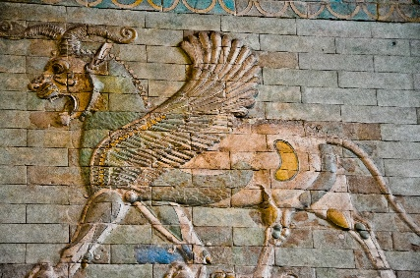
The first beast is relatively easy to identify. The winged eagle was the symbol of Babylon and was on many of its architectural creations. This was used to identify them with the protective deity Lamassu.
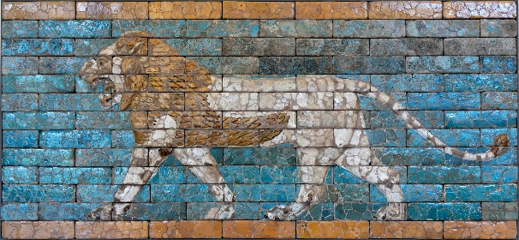
In addition, Jeremiah 4:6-13 predicts the invasion of Judah by Babylon, in verse 7 describing Babylon as a Lion, in verse 13 describing them as swifter than eagles. But then Nebuchadnezzar had his experience living as a wild beast. His wings had been plucked, but he returned to sanity and stood up as a man. Interestingly, the later artwork of the era uses a lion without wings instead of a winged lion.

Bear – Medo-Persia‌ Daniel 7:5
5 "And behold, another beast, a second one, resembling a bear. And it was raised up on one side, and three ribs were in its mouth between its teeth; and thus they said to it, ‘Arise, devour much meat!’
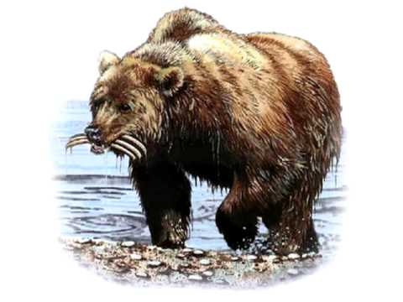
When Cyrus conquered Babylon with his general Ugbaru, the Kingdom of Babylon was usurped by the Medo-Persian Empire. Unlike a lion, which only eats meat, the bear will eat meat, but most of its food consists of plants and bugs. In the same way, Babylon consumed and absorbed every aspect of the countries it conquered, but the Medo-Persians used the resources, but tended to leave other cultures basically intact. Notice that the bear is lopsided, this reflects the fact that, although theoretically equal, Persia was significantly stronger than Medes.
The bear also has three ribs in its mouth. The traditional interpretation is that these represent the Lydian, Egyptian and Babylonian kingdoms that the Medo-Persian Empire conquered. I can find nothing in scripture to prove or disprove this, so take it as you will.

Leopard – Alexander’s Greece‌ Daniel 7:6
6 "After this I kept looking, and behold, another one, like a leopard, which had on its back four wings of a bird; the beast also had four heads, and dominion was given to it.
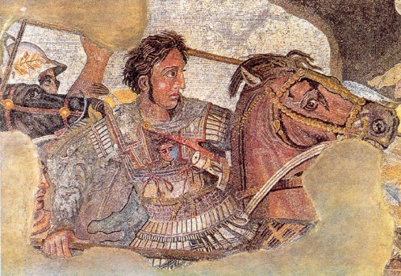
Critics claim that Daniel’s description of the first two empires is based on what he observed. He lived and ruled in both of these kingdoms. But Daniel was not alive for the empires that followed, so if this message is not from God, you would expect these to be far less accurate, after all Daniel died 200 years before the Medo-Persian empire ended.
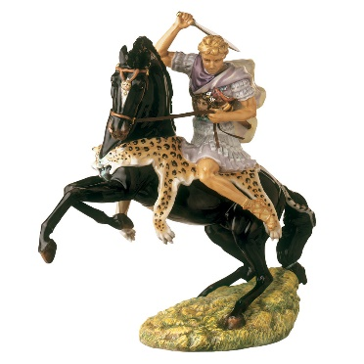
Daniel’s dream describes the next empire as a leopard, but a leopard with 4 wings and 4 heads. There are a couple interesting connections between alexander and the leopard. If you look closely at the artwork, found under the ashes in a house in Pompeii, you will notice the pattern around the horse’s shoulders. Here is a more contemporary artwork based on the historical description of Alexander. But there is an even stronger connection. The Leopard is fast. Alexander conquered all of the civilized world in between 11 and 13 years. His troops moved so fast that the supply lines could not keep up with them.
When Alexander laid siege to the fortress of Sogdian, the defenders told him he would need “men with wings” to capture it. That night about 300 of Alexander’s men scaled the fortress walls. In the morning, as his men were waving linen cloths from their arms to signal success, Alexander told the Sogdian defenders that he had found his winged men. The defenders were so demoralized that they surrendered without a battle. Others believe the wings refer to the four types of soldiers he used: light cavalry, heavy cavalry, light infantry and heavy infantry,
When Alexander was dying, his servants asked who should rule the empire since he had not heirs, his answer was, “to the strongest.” Immediately following his death, the four generals in charge of his army, Cassander, Ptolemy, Antigonus, and Seleucus began to battle over the kingdom and eventually divided it into four separate kingdoms. All four had similar attitudes, but they did not get along, there were four heads.

Fourth Beast –Roman Republic and Empire‌ Daniel 7:7a
7 "After this I kept looking in the night visions, and behold, a fourth beast, dreadful and terrifying and extremely strong; and it had large iron teeth. It devoured and crushed and trampled down the remainder with its feet;
In Daniel’s vision, the first three kingdoms looked like animals he knew, but when the fourth beast arose from the sea, it did not look like anything Daniel recognized. It was powerful and tough, causing fear in the hearts of all. It erased all distinctives of those kingdoms it conquered. One of the biggest dangers to any carnivore is damaging their teeth while eating, but with Iron Teeth, this kingdom was not concerned about anything happening to it. In all, this is a very accurate description of the Roman empire.
If God can, in advance, chart the empires of the world, He also knows what is best for you, will you trust Him or try to do things your own way?

Thrones Set up and God rules – the eternal kingdom right now ‌ Daniel 7:9-10,16
9 ¶ "I kept looking Until thrones were set up, And the Ancient of Days took His seat; His vesture was like white snow And the hair of His head like pure wool. His throne was ablaze with flames, Its wheels were a burning fire. 10 "A river of fire was flowing And coming out from before Him; Thousands upon thousands were attending Him, And myriads upon myriads were standing before Him; The court sat, And the books were opened.
16 "I approached one of those who were standing by and began asking him the exact meaning of all this. So he told me and made known to me the interpretation of these things:
In the first coming, God welcomed his followers into His eternal kingdom. His throne was established, and then, according to Luke 20:42-43, Acts 2:34-35, Hebrews 1:13 and Hebrews 10:13, God told his Son to sit at His right hand. Throne for the Father, Throne for the Son.
God sits on the throne, the white hair referring to his purity and wisdom, the fire referring to judgment of sin.
- White Hair: Purity and Wisdom
- Fire: Judgment of sin.
John 16:7-11 tells us that the Holy Spirit is working to convict the world of sin, righteousness and judgment. So the fire flowing from the throne is the work of the Holy Spirit.
Some commentators think that those standing before Him are the angelic hosts. I think they are wrong because the purpose of most Angels is to be sent by God. I think those standing before the thrones are the believers of the ages. Those who died before Christ with faithful expectation of the coming Messiah and those who believed in Jesus after his death and resurrection are joined as one. Those believers who have died are physically there, those believers who are alive are spiritually there. If you are a believer then those before the throne include you and me.
There are two heavenly books that are mentioned in scripture. The book of the Law and the book of Life. If your name is written in the Lamb’s book of life, we will be judged by what is in them. If someone’s name is in the book of Life, their judgment will be rewards for faithfulness to Christ. If their name is not in the book of life, then they will be judged for each point where they have failed God’s law. 1 Peter 4:17 tells us that Judgment begins with the house of God, and that it begins IN us. The judgment of non-believers will be at the end of the present age.
Are you going to be judged right now as part of God’s House, or wait to be judged later by the law?

Daniel 7 - the Four Beasts Prophecy - Part 1

Rulers and nations are appointed by God
Daniel 7:1-3,15
- Wind: Holy Spirit
- Sea: The non-Jewish nations / the gentile nations
- Beasts: Nations and Rulers
- Those standing by: God’s people Daniel 7:10

The four beasts‌ Daniel 7:4-7

Lion – Babylon‌ Daniel 7:4

Bear – Medo-Persia‌ Daniel 7:5

Leopard – Alexander’s Greece‌ Daniel 7:6

Fourth Beast –Roman Republic and Empire‌ Daniel 7:7a
If God can chart the empires of the world, He also knows what is best for you.
Will you trust Him or try to do things your own way?

Thrones Set up and God rules – the eternal kingdom right now‌ Daniel 7:9-10,16
Luke 20:42-43, Acts 2:34-35, Hebrews 1:13 and Hebrews 10:13, God told his Son to sit at His right hand
- White Hair: Purity and Wisdom
- Fire: Judgment of sin.
John 16:7-11 the Holy Spirit is working to convict the world of sin, righteousness and judgment
If you are a believer those before the throne include you and me.
Two heavenly books: the book of the Law and the book of Life.
Are you going to be judged as part of God’s House, or by the law?

Daniel 7 - the Four Beasts Prophecy - Part 1

Rulers and nations are __________________ by God
Daniel 7:1-3,15
- ________: Holy Spirit
- ______: The non-Jewish nations / the gentile nations
- ____________: Nations and Rulers
- Those standing by: __________ people Daniel 7:10

The ________ beasts‌ Daniel 7:4-7

________ – Babylon‌ Daniel 7:4

________ – Medo-Persia‌ Daniel 7:5

______________ – Alexander’s Greece‌ Daniel 7:6

____________ __________ –Roman Republic and Empire‌ Daniel 7:7a
If God can chart the empires of the world, He also knows what is best for you.
Will you trust Him or try to do things your own way?

Thrones Set up and God rules – the eternal kingdom right now‌ Daniel 7:9-10,16
Luke 20:42-43, Acts 2:34-35, Hebrews 1:13 and Hebrews 10:13, God told his Son to sit at His right hand
- __________ ________: Purity and Wisdom
- ________: Judgment of sin.
John 16:7-11 the Holy Spirit is working to convict the world of sin, righteousness and ________________
If you are a believer those before the throne ______________ you and me.
Τwo heavenly books: the book of the ______ and the book of ________.
Are you going to be judged as part of __________ __________ or by the law?

“Jesus said to them, "I am the bread of life; he who comes to Me will not hunger, and he who believes in Me will never thirst.” (Joh 6:35 NAS95)
“"I am the vine, you are the branches; he who abides in Me and I in him, he bears much fruit, for apart from Me you can do nothing.” (Joh 15:5 NAS95)
“48 "I am the bread of life. 49 "Your fathers ate the manna in the wilderness, and they died. 50 "This is the bread which comes down out of heaven, so that one may eat of it and not die. 51 "I am the living bread that came down out of heaven; if anyone eats of this bread, he will live forever; and the bread also which I will give for the life of the world is My flesh." 52 Then the Jews began to argue with one another, saying, "How can this man give us His flesh to eat?" 53 So Jesus said to them, "Truly, truly, I say to you, unless you eat the flesh of the Son of Man and drink His blood, you have no life in yourselves. 54 "He who eats My flesh and drinks My blood has eternal life, and I will raise him up on the last day. 55 "For My flesh is true food, and My blood is true drink. 56 "He who eats My flesh and drinks My blood abides in Me, and I in him. 57 "As the living Father sent Me, and I live because of the Father, so he who eats Me, he also will live because of Me. 58 "This is the bread which came down out of heaven; not as the fathers ate and died; he who eats this bread will live forever."” (Joh 6:48-58 NAS95)

