John 2:1-11
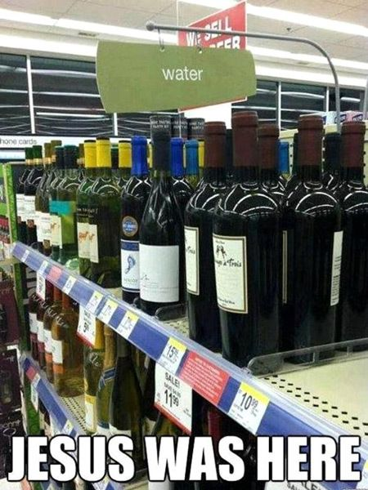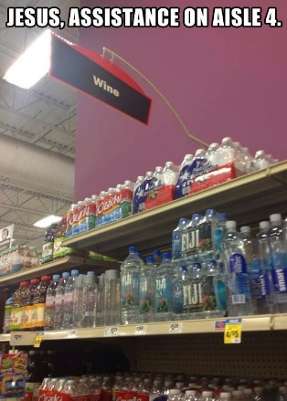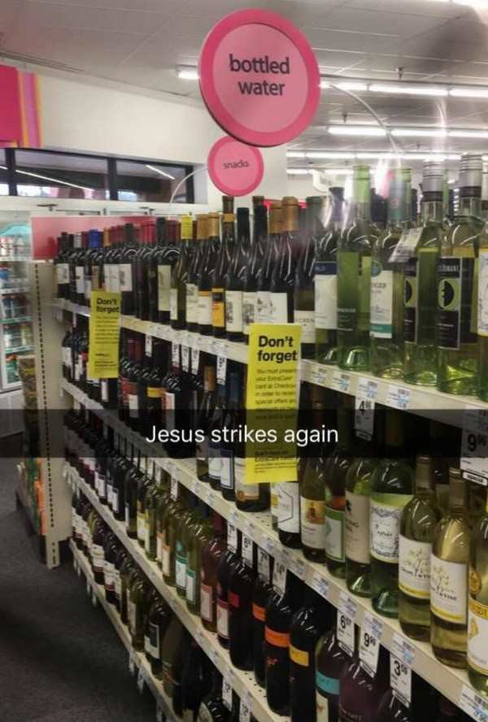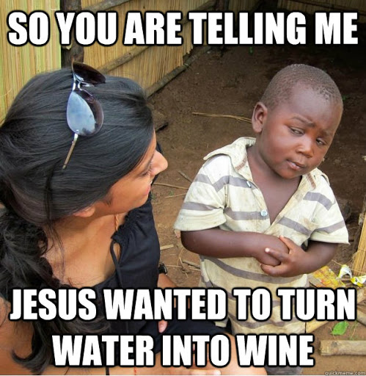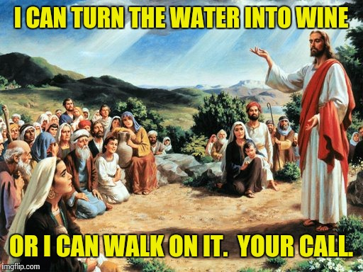
For most of the years while I was growing up, my father ran his own business as a wedding photographer. My first job was working for his business…I made 25¢ per hour to sand the ugly yellow paint off an old filing cabinet. As I grew older, I started going with him to the weddings. I have been to more weddings than I can count, some big, some small. I saw parents who were happy, parents who were drunk and parents who made a fuss because they were not the center of attention. Some of the brides were kind, others were Bridezillas. Some of these marriages ended in weeks, others are likely still going strong over 35 years later.
One wedding was at Whitehouse Ranch Chapel, which holds 15 people, including the preacher, bride and groom. Others filled churches that held many hundreds of people, with twelve bridesmaids and 12 groomsmen. Some had huge events with steak and lobster at the Broadmoor hotel where the wedding party used Gold Flatware and all the guests used real silverware. Others had cake and punch in the church fellowship hall or invited a few special people to join them for lunch at a local restaurant. Some receptions got done in an hour, others lasted until 2 or 3 in the morning.
Among all of those, I was never at a wedding like the one Jesus attended with his disciples. The Jewish marriage was arranged by the Father of the Groom, who paid a price to bring the bride into his family. Once the bride price was paid, there would be a large celebration for the betrothal. The couple was now legally bound, and to end this betrothal would require a divorce even though they were not yet married. At the end of the betrothal party, the son would then have to go prepare a place for his bride, usually by adding a new room onto his family’s home, and promised to return for her when the place is ready. Typically, this time of preparation would take about a year. He could only go claim his bride when his father declared that the place he prepared was ready. The son would let the bride know when he was getting close, but would not know the exact day or hour, only the father would know.
When the father said the time was right, all the relatives would then be invited to the marriage feast. The son would go and claim his bride, bringing her to the place he prepared for their marriage and then throw a marriage feast which could last from 3 to 7 days and everyone in anyway connected to the families would be invited to the feast.
Now think about how this parallels our salvation, God the Father arranged a bride (us) for His Son (2 Corinthians 11:2). The price was paid through the death of Jesus (1 Corinthians 6:20). When someone repents and becomes the Bride of Christ, there is rejoicing and celebration in heaven (Luke 15:10). We are legally bound to Christ at the moment of salvation (2 Corinthians 11:2). The son has been sent to prepare a place for us and promised to return (John 14:1-3). Jesus does not know the exact time when the Father will declare the place is ready (Matthew 24:26), but has alerted us through prophecy that the time is getting close. At his second coming, we will join in the marriage supper of the Lamb (Revelation 19:7-8).
Obviously, marriage is an important to our life with Christ, so it seems appropriate to look at the only human marriage recorded in the New Testament to learn how it applies to our life. As we read John 2:1-11, we learn that Jesus knows the timing God has ordained. We see that God’s ways are not our ways. We see that God abundantly provides the best. Finally we see a theme that runs throughout the book of John of Jesus miracles being signs that He is God and savior of the world.
Keep in mind that wine is often used in scripture as a symbol of God’s blessings, of the Holy Spirit in believer’s lives, and of the blood of Jesus shed for our redemption.

Jesus knows the timing John 2:1-4
“1 ¶ On the third day a wedding took place at Cana in Galilee. Jesus’ mother was there, 2 and Jesus and his disciples had also been invited to the wedding. 3 When the wine was gone, Jesus’ mother said to him, "They have no more wine." 4 "Dear woman, why do you involve me?" Jesus replied. "My time has not yet come."
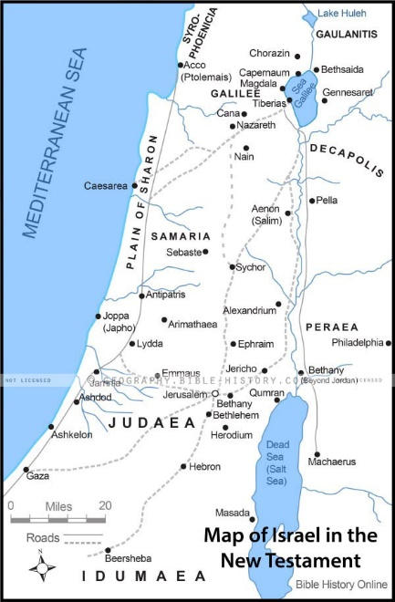
In chapter 1, we saw Jesus being baptized in the Jordan (1) and then traveling up into the Galilee region (2) and meeting the disciples that were from Bethsaida (3), but not really an indication of why he was traveling. Here we find out that he was traveling to a marriage celebration in Cana (4). Even in this trip, we see the timing, He traveled north for a wedding, and to meet His new disciples. As the party went on, the host had a problem. It was socially offensive to tell the wedding guests that you had run out of wine or anything else that they needed. It is likely that Mary was related to the hosts and didn’t want the family to be shamed by running out of supplies.
Two tactics were usually used to make sure that the wine lasted. 1st they would serve the good quality stuff at the beginning and then serve lower quality wines later on when people were a little inebriated. Secondly, they would water down the wine some as the party went on. But still, in this case, they were out of wine, so she came to Jesus and told Him to do something about the problem. I doubt if she wanted Him to do a miracle, more likely she was doing the perfectly normal thing of asking Him to go buy more wine from the merchants. She had to be confused when He said, “my time has not yet come.”
The trend of the gospels is that early in His ministry, Jesus asked people to keep his miracles quiet and not tell anyone. Later on, He was far more open about both His miracles and His status as the messiah. The scripture is not clear on why He changed tactics, but I have a theory. Early on in His ministry Jesus was focused on selecting and training a small group of disciples. As the disciples were selected, they were not ready to deal with the crowds. Jesus spent the majority of his ministry training the disciples and showing them how to minister to people. It was only in the final period of His ministry, when his time had come, that Jesus was more public, when the disciples were ready to continue, share and teach the things that He had taught them. Jesus still did miracles and ministered to people, but His focus was on the individuals and not the crowds.
As our church works to reach the community, we need to take a similar attitude. We need to invest in individuals while opening the door to the community. We need to help each person that comes in these doors to grow as a disciple. As we pray for God to send laborers into the harvest, we cannot ignore the labor pool that is in the harvest.

God’s ways are not our ways John 2:5-8
5 His mother said to the servants, "Do whatever he tells you." 6 Nearby stood six stone water jars, the kind used by the Jews for ceremonial washing, each holding from twenty to thirty gallons. 7 Jesus said to the servants, "Fill the jars with water"; so they filled them to the brim. 8 Then he told them, "Now draw some out and take it to the master of the banquet." They did so,
As I said, I think Mary expected Jesus to go buy more wine. When she told the servants to do whatever He said, she probably expected Him to tell them which wine dealer to pick up the wine from. The wine was typically sold in an amphora that held about ten gallons of wine, so it would have weighed about 90 pounds per container. Jesus had other ideas.
The Jews ceremonially washed their hands and arms before and after meals, after using the toilet, and before prayer. Each hand from mid arm to finger tips would have at least a half cup of water poured over it, alternating left and right hands until they each has been washed three times and then pour at least an additional cup of water over both hands at once, followed by drying them with a towel. If they had 6 – 20 gallon containers of water, that was enough for about 200 people to ceremonially wash for a week.
The servants had to think Jesus was crazy as he told them to fill the ceremonial washing jars to the rim and then serve it as wine to the master of the banquet. If running out of wine was an offense, serving washing water as a drink was even more so. They had to approach with fear and trembling. Who knows what the master of the banquet was going to do to them when He drank the water.
At times God will ask you to do things that make no sense. By the world’s standards, much of what we do and believe as Christians doesn’t make sense. We believe in the existence of non-human beings in another plane of reality. We believe that when Jesus was crucified it was a spiritual means of reconciling a corrupted world with divine perfection. God will ask you to sacrifice your comfort to reach out to others. It may make no sense, but trust God to not only know what He is doing, but to do things beyond what you could ever expect.

God abundantly provides the best John 2:9-10
9 and the master of the banquet tasted the water that had been turned into wine. He did not realize where it had come from, though the servants who had drawn the water knew. Then he called the bridegroom aside 10 and said, "Everyone brings out the choice wine first and then the cheaper wine after the guests have had too much to drink; but you have saved the best till now."
This is a side note, but our perceptions are directly influenced by our past knowledge. If the master of the banquet had known where the wine came from, would he have been willing to try it? If he had tasted it, would he have a preconceived idea about it? Do you expect something different from a person when they come from the city of DeWitt than when they come from the south end of DeWitt township? Perhaps we all need to lay aside our preconceived notions and experience reality as God puts it in our path.
Assuming 200 guests, if the servants had purchased 10 gallons of wine, it would have been enough for each person at the wedding to have two or three modern BOTTLES of wine. Turning 6 – 20-30 gallon containers into wine would have given each of those 200 people 30-50 bottles of wine each. Jesus didn’t just give them enough to be socially acceptable, he gave them wine in abundance.
Again, as a side note: We know that the wine Jesus made was alcoholic by the master of the banquet’s reaction. He said that everyone brings out the good stuff first and then the cheap stuff after everyone is drunk. If he was given grape juice, I cannot believe that he would say it was better than the stuff that made people drunk. But whether the wine contained alcohol is not the important point of the passage. This does not necessarily advocate drinking but reflects the reality of their culture. Water born diseases could kill you, wine would not.
Look at what he says: “but you have saved the best till now.” When the master says, “the best” it indicates the quality was above par. When God chooses to act, you can be sure that He will give you the best, and the best He could give is His own son.

The first sign John 20:11
11 This, the first of his miraculous signs, Jesus performed at Cana in Galilee. He thus revealed his glory, and his disciples put their faith in him.” (Joh 2:1-11 NIVUS)
As we journey through the book of John we are going to see seven signs. In each of these, Jesus does something that proves He is God. He establishes His authority all of creation. John records this as the first of the signs…turning water into wine.

Communion
Many times throughout His ministry, Jesus again returns to wine. Turn over to John 6:48. Jesus says:
“48 I am the bread of life. 49 Your forefathers ate the manna in the desert, yet they died. 50 But here is the bread that comes down from heaven, which a man may eat and not die. 51 I am the living bread that came down from heaven. If anyone eats of this bread, he will live forever. This bread is my flesh, which I will give for the life of the world." 52 Then the Jews began to argue sharply among themselves, "How can this man give us his flesh to eat?" 53 Jesus said to them, "I tell you the truth, unless you eat the flesh of the Son of Man and drink his blood, you have no life in you. 54 Whoever eats my flesh and drinks my blood has eternal life, and I will raise him up at the last day. 55 For my flesh is real food and my blood is real drink. 56 Whoever eats my flesh and drinks my blood remains in me, and I in him. 57 Just as the living Father sent me and I live because of the Father, so the one who feeds on me will live because of me. 58 This is the bread that came down from heaven. Your forefathers ate manna and died, but he who feeds on this bread will live forever." 59 He said this while teaching in the synagogue in Capernaum.” (Joh 6:48-59 NIVUS)
The Jews thought Jesus was offering cannibalism, but what he was offering was so much more. We know that Jesus meant participating in His death and resurrection.
Before we participate in communion, we need to understand the significance of what is happening. In 1 Corinthians 11:26-32 we read:
“26 For whenever you eat this bread and drink this cup, you proclaim the Lord’s death until he comes. 27 Therefore, whoever eats the bread or drinks the cup of the Lord in an unworthy manner will be guilty of sinning against the body and blood of the Lord. 28 A man ought to examine himself before he eats of the bread and drinks of the cup. 29 For anyone who eats and drinks without recognizing the body of the Lord eats and drinks judgment on himself. 30 That is why many among you are weak and sick, and a number of you have fallen asleep. 31 But if we judged ourselves, we would not come under judgment. 32 When we are judged by the Lord, we are being disciplined so that we will not be condemned with the world.” (1Co 11:26-32 NIVUS)
What does it mean to be worthy of communion?
- Being worthy means recognizing that the bread and juice represent the sacrifice of Christ by which we are redeemed from sin. Therefore, to participate in communion while not accepting Jesus as your savior and Lord would be to take it in an unworthy manner.
- Being worthy means having a clean conscience. So taking the supper with willful, unconfessed sin would be in an unworthy manner.
- Being worthy means not holding animosity against other people. So holding a grudge against another person would make you unworthy until you are reconciled.
Being worthy, does not however mean being perfect.
Before we partake of the bread to examine yourself while Jan plays and ensure that you are partaking in a worthy manner. If you don’t know Jesus as your savior and Lord, or if you have any other prayer request, you can come talk to me during this time. Also during this time, if you need a gluten free alternative, you can come forward during this time as well.
[[Jan plays]]
“31 ¶ Now it was the day of Preparation, and the next day was to be a special Sabbath. Because the Jews did not want the bodies left on the crosses during the Sabbath, they asked Pilate to have the legs broken and the bodies taken down. 32 The soldiers therefore came and broke the legs of the first man who had been crucified with Jesus, and then those of the other. 33 But when they came to Jesus and found that he was already dead, they did not break his legs.” (Joh 19:31-33 NIVUS)
“These things happened so that the scripture would be fulfilled: "Not one of his bones will be broken,"” (Joh 19:36 NIVUS)
In the pew in front of you, you should see a small cup. Peal of the top wrapper to find a wafer. This wafer is the bread that represents the body of Christ. As you take it, remember Christ’s body. Remember that the breaking of the bread is not to symbolize breaking bones, but to symbolize him being broken off from the land of the living.
[Dave? Tom? Saundra?] Please pray for the Bread of Christ’s Body…..
Take and eat in remembrance of Christ’s sacrifice and contemplate while Amy plays.
“Instead, one of the soldiers pierced Jesus’ side with a spear, bringing a sudden flow of blood and water.” (Joh 19:34 NIVUS)
After [-_________] prays, please take the juice remembering Christ’s shed blood on our behalf.

Closing prayer – Kevin

John 2:1-11
God the Father arranged a bride (____) for His Son
2 Corinthians 11:2
The __________ was paid through the death of Jesus
1 Corinthians 6:20
We repent and are engaged as the __________ of Christ Luke 15:10
We are __________ to Christ at salvation
2 Corinthians 11:2
The son went to ______________ a place for us & promised to return John 14:1-3
Jesus ______________ know when God will be ready Matthew 24:26
We will join in the marriage ____________ of the Lamb Revelation 19:7-8

Jesus knows the timing John 2:1-4
In His ministry, when his ________ had come, Jesus was more public.
We need to help each person to ________ as a disciple.

God’s ways are not our ways
John 2:5-8
At times God will ask you to do things that make ____ __________.
God will ask you to sacrifice your ______________ to reach out to others.

God abundantly provides the best John 2:9-10
We need to lay aside our preconceptions and experience ______________ as God puts it in our path.
When God chooses to act, you can be sure that He will give you the ________

The first sign John 20:11
In each of these, Jesus does something that ____________ He is God.

